CIS440 Personal Project

Michael Buckley

This is a two-screen app for iOS using swift. The first screen contains a table view where the to-do list array is displayed. The second screen contains labels, a text field, and a button that will add to-do items to the array, which is displayed in the table view.

I included screenshots of the app and its functions with descriptions of each screen shot.

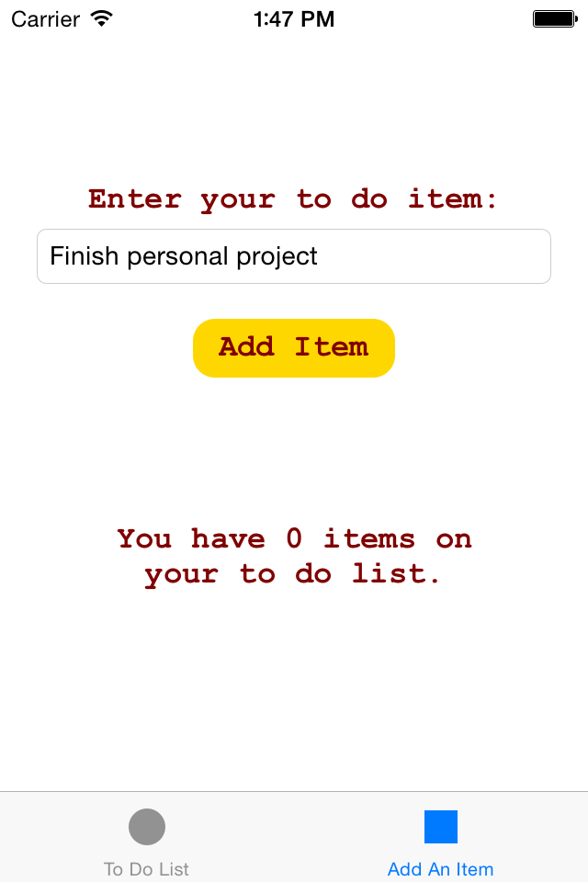

Here I am adding my first item to the to do list.

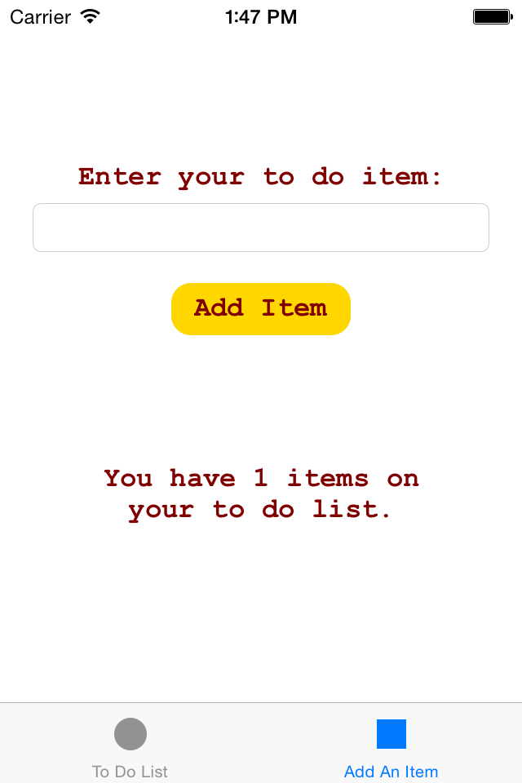

After clicking add item the label on the bottom of the screen displays how many items are on the to do list.

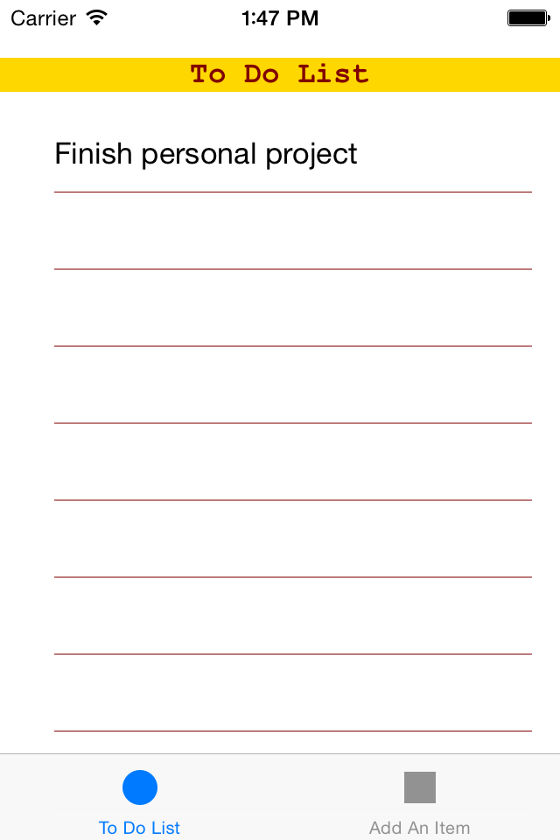

This is the To Do List tab which now has the new to do item.

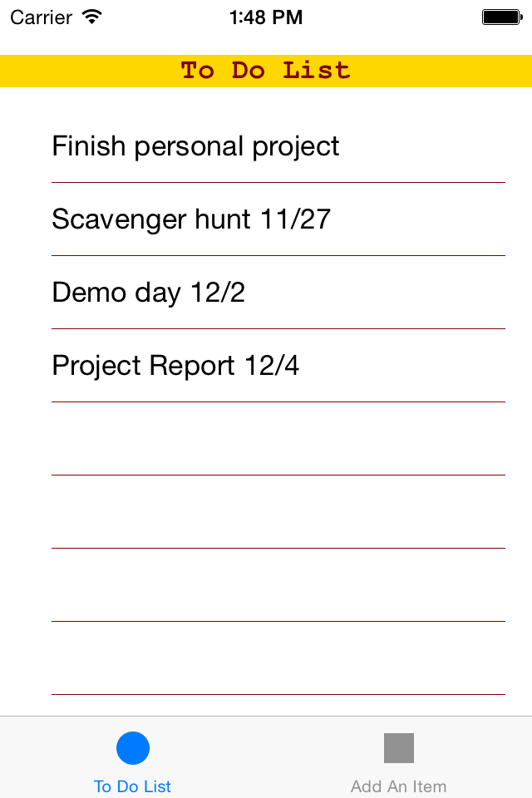

I have added more items to the to do list.

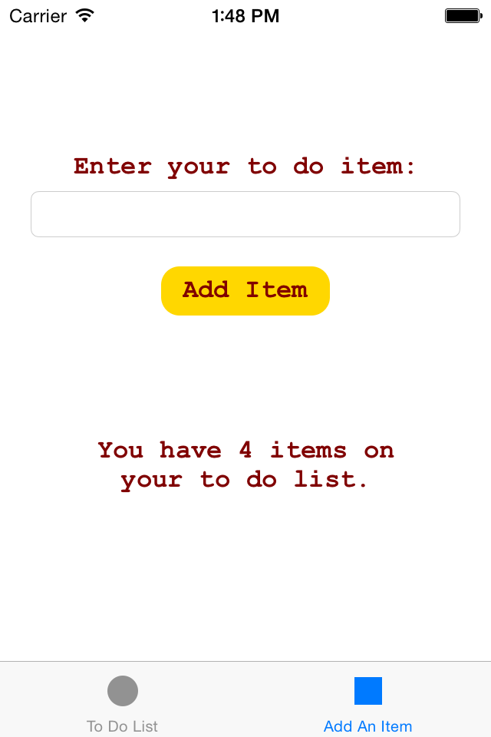

Now the label displays 4 items are on the to do

List.

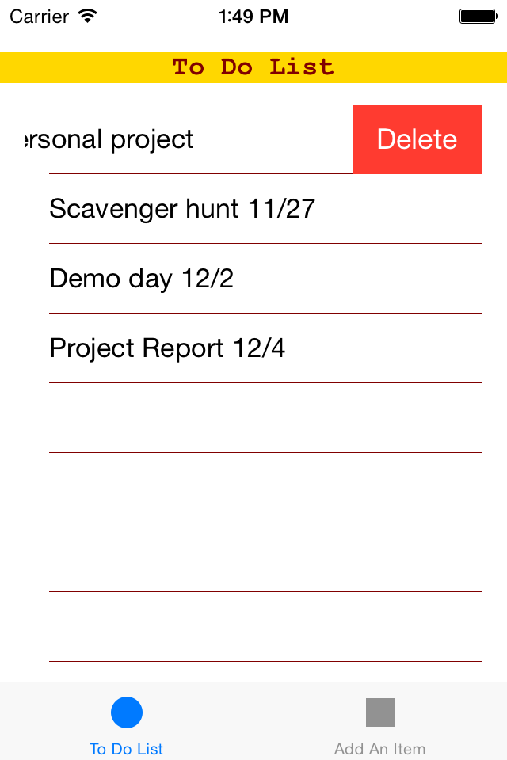

Here I am deleting one item from the to do list.

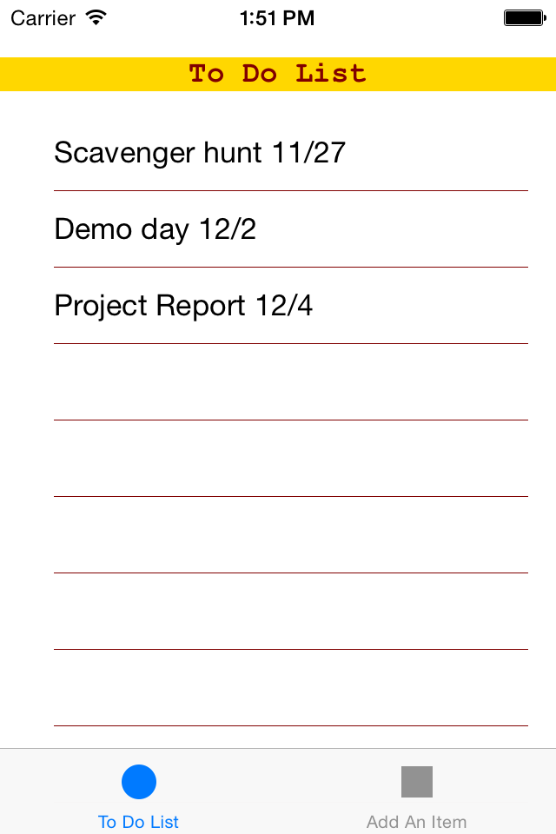

The item has been deleted and the table view

now displays the array with all the items moved

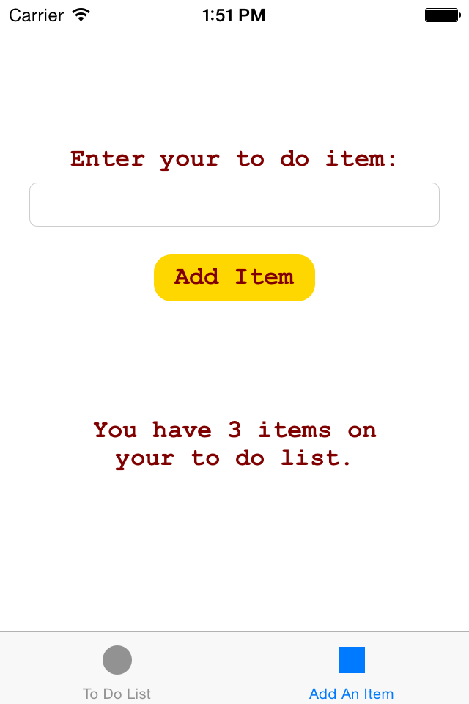 up one row.

The Add An Item tab now displays there are 3

Items on my to do list after one was deleted.

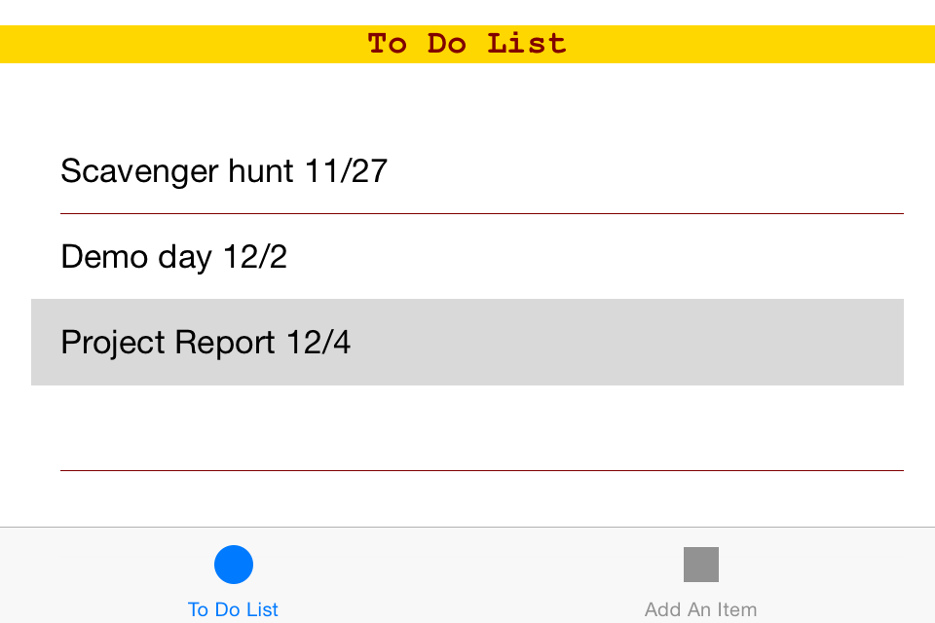There are constraints on the fields which allow the app to be rotated and keep the same functionality.